**Mean Shift Algorithm Inference:**Parameters tuned – **SP** and **SR** (used for neighbor identification)

***IMAGE - Parameter List: SP= 1 SR=10***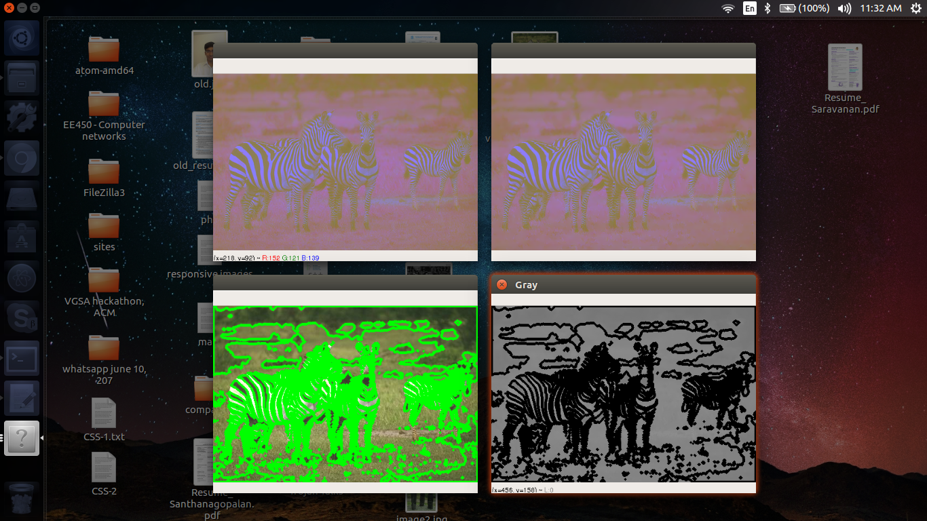

***IMAGE - Parameter List: SP= 1 SR=20***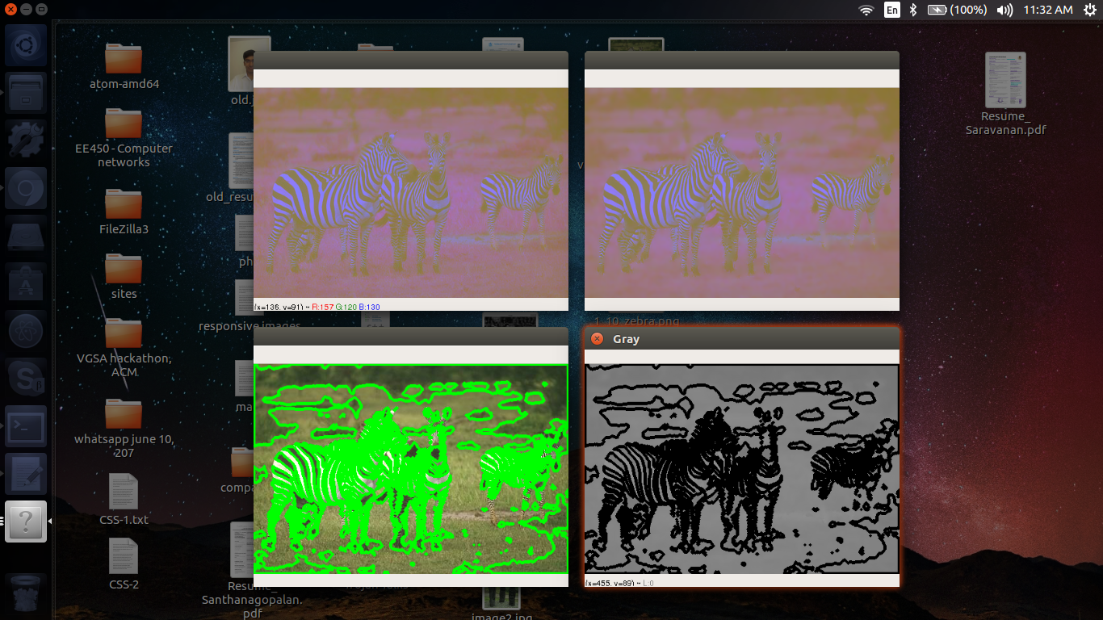

**Observation (SR):**   
Increasing **SR** leads to vanishing segment boundaries and unifications. This is quite evident from the results corresponding to the parameter lists (**SP**=1, **SR**=10) and (**SP**=1, **SR**=20) on **image3**.

**Inference (SR):**   
The reason for this phenomenon is easy to understand. As we increase the value of **SR**, the threshold for being considered as a neighbor decreases since we allow pixels with greater distances (in color) to be considered close.   
  
***IMAGE - Parameter List: SP= 1 SR=20***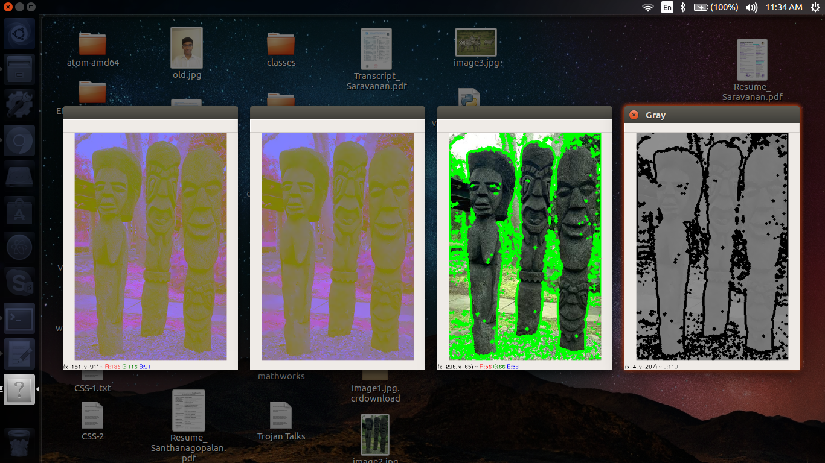

***IMAGE - Parameter List: SP= 10 SR=20***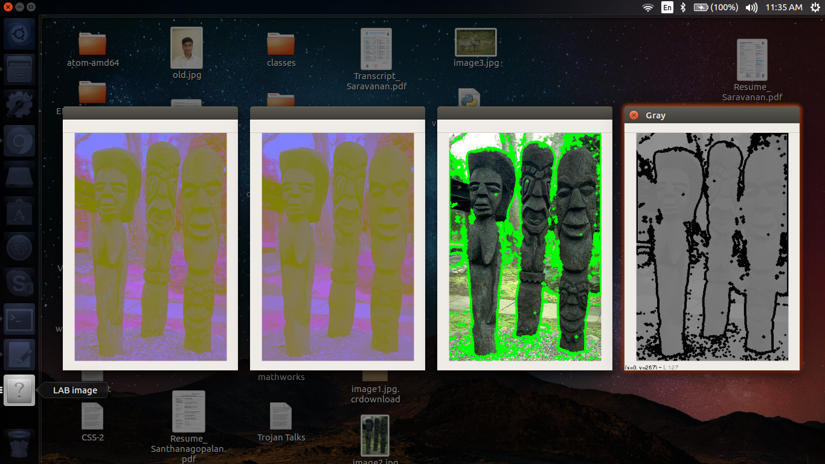**Observation (SP):**Increasing **SP** leads to noise and background filtering. The high intensity features of the image get enhanced while the smaller and less significant parts die out. This is evident from the results obtained by using the parameter lists (**SP**=1, **SR**=20) and (**SP**=10, **SR**=20) on **image2**.

**Inference (SP):**The reason for this lies in the core of the algorithm. As we increase the radius of the window, potentially smaller segments start converging on to their neighbors. This is because the net overall mean of the window is no longer convergent within the independent segment due to the effects of pixels outside of it.

**Proposal for tuning:**

* From our experiments, we observe that the parameters are tunable for individual image cases to improve performance.
* Construct a data set of images under different lighting/backgrounds for your particular use-case (Tracking a car, tracking a pedestrian, tracking a ball in a soccer field, etc.,)
* Consider a particular image and tune **SP** by increasing progressively its value until you observe the desired level of background/noise filtering.
* Now for this image, tune **SR** by increasing progressively until a desired level of abstraction is obtained. By abstraction, we refer to the level of aggregation of segments that is desirable. For example, it might be suffice to just identify an animal on **image3** or it could be important that the stripes be detected and a consequent inference of a zebra.
* Test out this parameter list on random samples from the data set and observe.
* Tune again for this particular case and take an average.
* Repeat the steps until convergence.

**Watershed Algorithm:**  
# Finding sure foreground area

dist_transform = cv2.distanceTransform(opening,cv2.DIST_L2,5)

ret, sure_fg = cv2.threshold(dist_transform,0.7*dist_transform.max(),255,0)

Parameters tuned – Coefficient of thresholding, **TH**

***IMAGE – Parameter: TH = 0.3***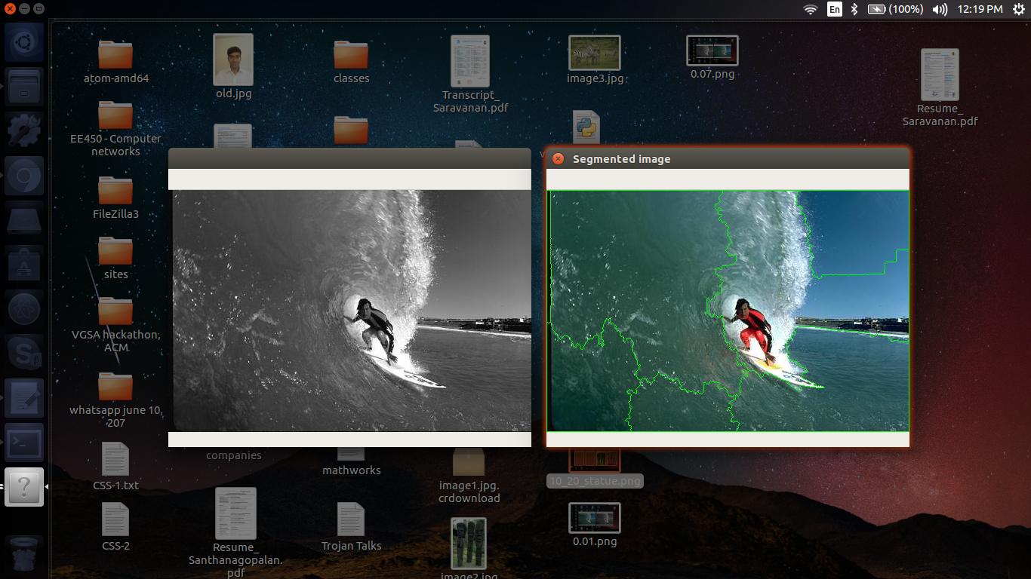

***IMAGE – Parameter: TH = 0.07  
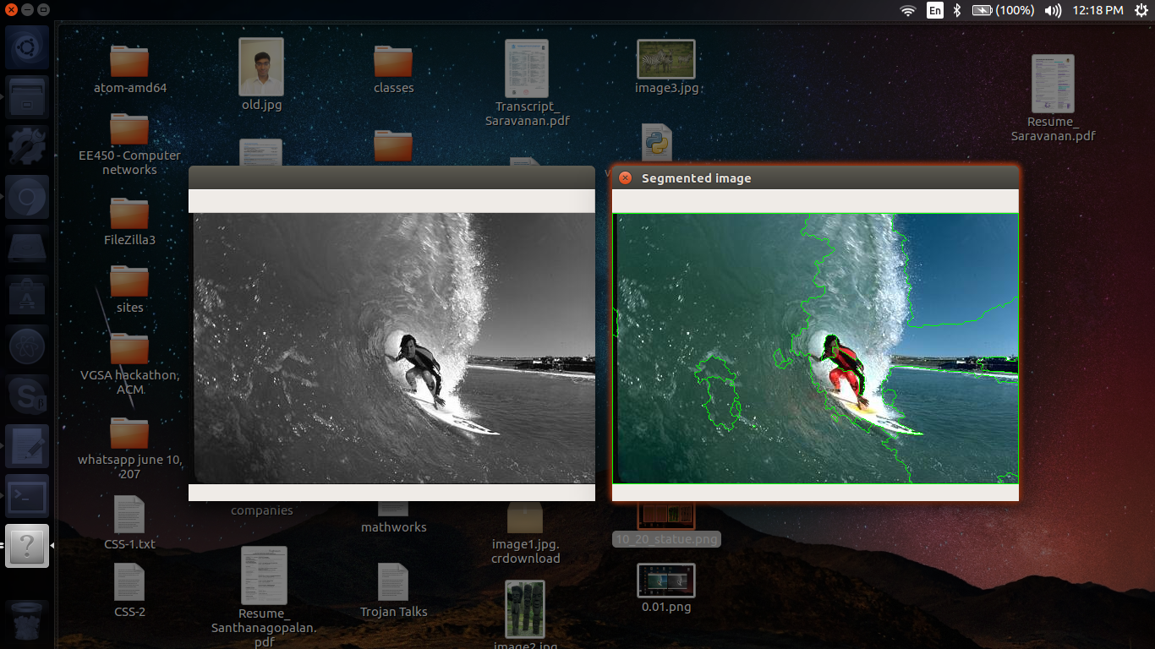***

***IMAGE – Parameter: TH = 0.07  
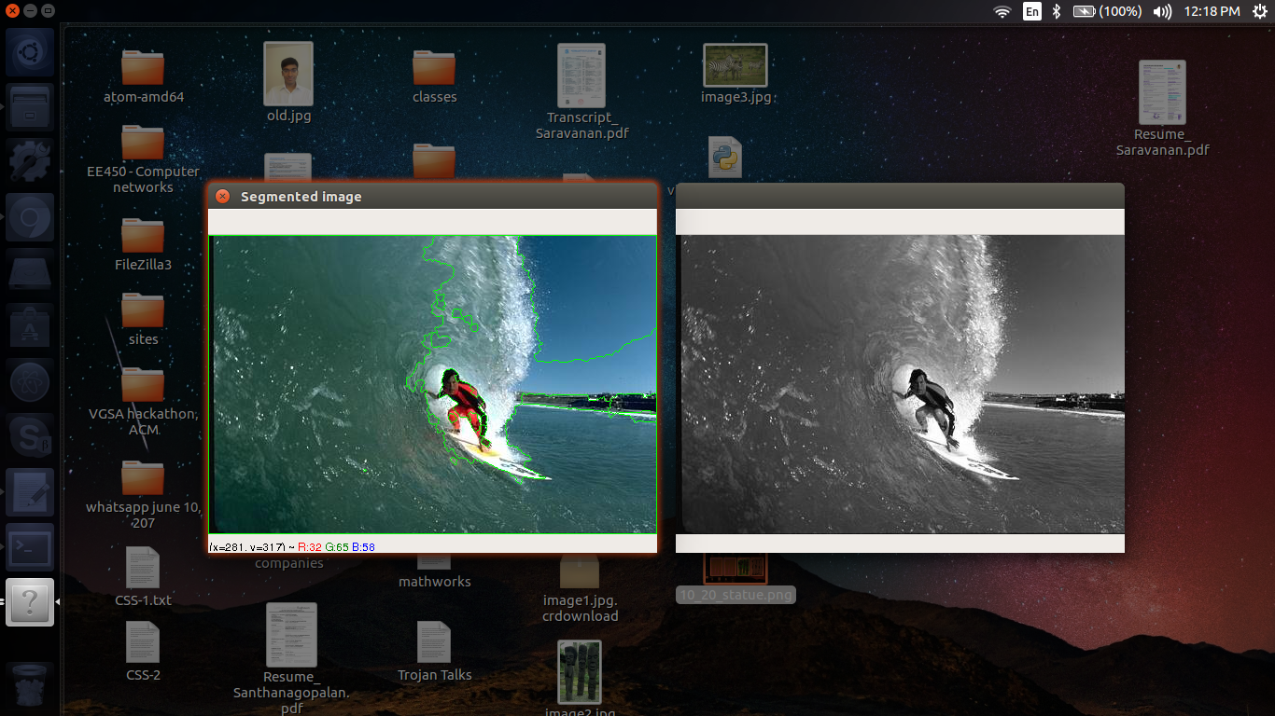***

**Observation:**With decreasing **TH** the important features of the image are getting enhanced and segmented while the noise and background gets filtered out. Beyond a particular value, further decrease in **TH** does not affect the results of segmentation.  
This is also evident from the improving performance of the algorithm as **TH** decreases from 0.3 -> 0.07 ->0.01 on **image1.**

**Inference:**The sure foreground area that gets threshold gets concentrated in the high intensity parts of the image. Thus, the noise in the background gets categorized as being a part of the background. Now when the foreground is subtracted from the background we obtain more desirable boundaries**.**

**Proposal for tuning:**Reduce **TH** until the desired characteristics of the image are identified and segmented.  
Another alternate could be to a have a particular number of segments as benchmark for a particular image and then vary **TH** iterativelyuntil we obtain a close enough output